University Of Engineering and Technology, Lahore
Computer Engineering Department

Course Name: Programming Fundamentals | Course Code: CMPE-112L
Assignment Type: Lab tasks | Dated: 2 March 2026
Semester: First | Session: 2026 Spring
Lab/Project/Assignment #: 1 | CLOs to be covered: CLO 1
Lab Title: For Loops | Teacher Name: Hafiz Muhammad Mubashar
Lab Evaluation:

CLO1 | Apply appropriate programming techniques to create executable programs to solve well defined problems
CLO1 | Level1 | Level2 | Level3 | Level4 | Level5 | Level6
(5)
Total |  |  |  |  |  | /5
Rubrics for Current Lab Evaluation
Scale | Marks | Level | Rubric
Excellent | 5 | L1 | Submitted all lab tasks, BONUS task, have good understanding.
Very Good | 4 | L2 | Submitted the lab tasks but have good understanding
Good | 3 | L3 | Submitted the lab tasks but have weak understanding.
Basic | 2 | L4 | Submitted the lab tasks but have no understanding.
Barely Acceptable | 1 | L5 | Submitted only one lab task.
Not Acceptable | 0 | L6 | Did not attempt
Week 2 LAB
For Loops
Lab Goals/Objectives:
• To understand and implement definite iteration using Python’s for loop.
• To learn how to iterate over sequences (like ranges and lists) and manipulate data during iteration.
• To apply conditional logic (if statements) inside loops for selective data processing.
Equipment Required:

* Computer/Laptop
* Python 3.14
* VS Code or pycharm

Theory:
In Python, a for loop is used to iterate over a sequence (such as a list, tuple, dictionary, set, or string) or a range of numbers. Unlike some other languages, Python's for loop acts more like an iterator method

Lab Work:

Task 1: Basic Range Iteration

for i in range(1, 6):
print(i)

Result:

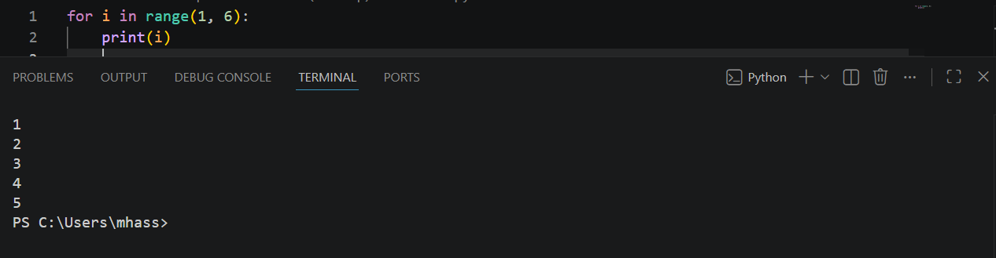

Task 2: List Iteration and Accumulation
marks = [80, 90, 75, 60, 85]
for m in marks:
total = total + m

Result:

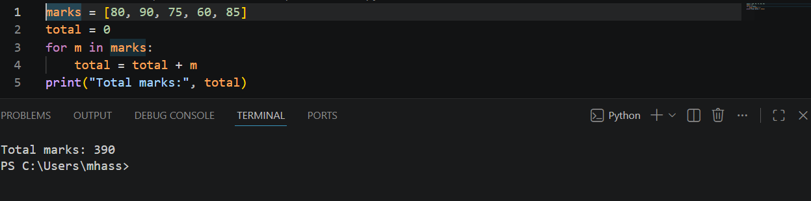

Task 3: Conditional Logic within a Loop.
for i in range(1, 11):
if i % 2 == 0:
print(i)

Result:
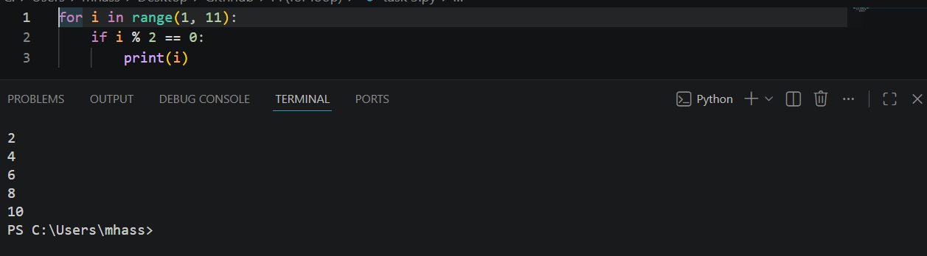

Task 4: Multiplication Table Generation.

for i in range(1, 11):
print(num, "x", i, "=", num * i)

Result:

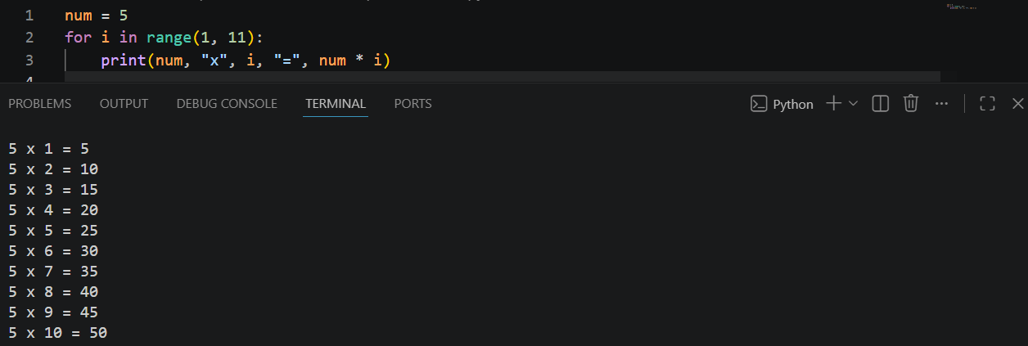

Conclusions:
This lab successfully demonstrates the utility of for loops in Python for handling repetitive tasks efficiently. By practicing with ranges, lists, and conditional statements, we covered the core fundamentals of iteration, data accumulation, and basic logic control. These building blocks are essential for writing clean, automated, and scalable code.

